**Assignment-4**

1. **Can two visually different image have same histogram? If yes, synthesize two grayscale images which are visually different but having same histogram and also show the histogram. If no, justify your answer.**

* Histogram is not a unique representation of an image.
* Histogram is a graph of gray value vs frequency of occurrence of gray value.It depends on the probability or frequency of gray value.
* So ,no matter how the gray values are distributed over the image,if the frequency of occurrence of gray value is not changed, the histogram will not change .Therefore, Histogram is not unique representation of images.
* That means it is possible that two or more different images can have same Histogram.

**Code:-**

clc;

clear all;

close all;

image1 = imread("./Ex1a.png");

image2 = imread("./Ex1b.png");

%load pakg image

pkg load image;

%check for histogram

figure;

imhist(image1);

imwrite(imhist(image1),"Ex1c.png");

figure;

imhist(image2);

imwrite(imhist(image1),"Ex1c.png");

%check if it's the same or not

isequal(histogram1,histogram2)

 

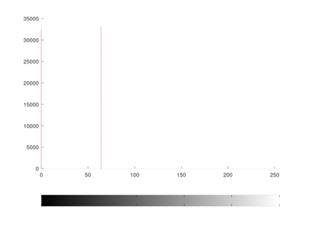 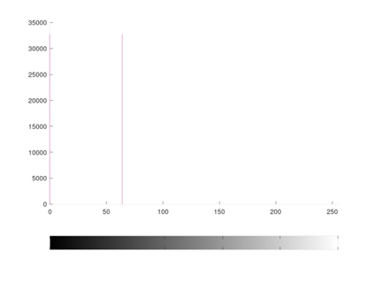

**User Function used in Exercise.**

1.MyHistogramEqualizer

function[output_image,frequncy_vector,equilze_vector_s]=

MyHistogramEqulizer(input_image)

img = input_image;

[m,n] = size(img);

L=256;

%find frequncy_vector out intensity rang is [0,255]

%fv is of size 1x256;

fv = zeros(1,L);

for i=1:L

fv(1,i) = sum(sum(img == (i-1)));

endfor

frequncy_vector = fv;

%find PDF for each intensity

PDF = fv/m/n;

%find a equilze_vector_s

s = zeros(1,L);

for i=1:L

temp = 0;

for j=1:i

temp = temp + PDF(1,j);

endfor

s(1,i) = round((L-1)*temp);

endfor

equilze_vector_s = s;

%create final image

final = zeros(m,n);

for i=0:255

final = final + (img==i)*s(1,i+1);

endfor

finalImg = uint8(final);

output_image = finalImg;

endfunction

1. MyHistogramMatcher

function output_image = MyHistogramMatcher(input_image,specific_image)

rImg = input_image;

spImg = specific_image;

[m,n] = size(rImg);

[final1,r_fv,r_s1] = MyHistogramEqulizer(rImg);

[final2,sp_fv,sp_g1] = MyHistogramEqulizer(spImg);

L=256;

for i=0:(L-1)

[value,index(i+1)] = min(abs(sp_g1-r_s1(i+1)));

endfor

index = index-1;

final = zeros(m,n);

for i=0:(L-1);

final = final+(rImg == i)*index(i+1);

endfor

finalImg = uint8(final);

output_image = uint8(finalImg);

Endfunction

1. **Take your color photograph taken in dark. Equalize it’s histogram.**

clc;

clear all;

close all;

%load the image;

a = imread("./7.jpg");

imshow(a);

%r channel histogram equilzation

[final(:,:,1),r_histogram_y,r_s] = MyHistogramEqulizer(a(:,:,1));

%figure;

%imshow(final(:,:,1));

figure;

plot(0:255,r_histogram_y);

title("r channel histogram");

%g channel histogram equlization

[final(:,:,2),g_histogram_y,g_s] = MyHistogramEqulizer(a(:,:,2));

%figure;

%imshow(final(:,:,2));

figure;

plot(0:255,g_histogram_y);

title("g channel histogram");

%b channel histogram equlization [final(:,:,3),b_histogram_y,b_s]= MyHistogramEqulizer(a(:,:,3));

%figure;

%imshow(final(:,:,3));

figure;

plot(0:255,b_histogram_y);

title("b channel histogram");

%see the final image

figure;

imshow(final);

imwrite(final,"Ex2d.png");

1. **Perform histogram equalization of equalized image obtained. Is second pass of the histogram equalization process useful? Justify your answer.**

clc;

clear all;

close all;

%load the image;

a = imread("./Ex2d.png");

imshow(a);

%r channel histogram equilzation

[final(:,:,1),r_histogram_y,r_s] = MyHistogramEqulizer(a(:,:,1));

%figure;

%imshow(final(:,:,1));

figure;

plot(0:255,r_histogram_y);

title("r channel histogram before EQ");

figure;

imhist(final(:,:,1));

title("r channel histogram after EQ");

%g channel histogram equlization

[final(:,:,2),g_histogram_y,g_s] = MyHistogramEqulizer(a(:,:,2));

%figure;

%imshow(final(:,:,2));

figure;

plot(0:255,g_histogram_y);

title("g channel histogram before EQ");

figure;

imhist(final(:,:,2));

title("g channel histogram after EQ");

%b channel histogram equlization

[final(:,:,3),b_histogram_y,b_s] = MyHistogramEqulizer(a(:,:,3));

%figure;

%imshow(final(:,:,3));

figure;

plot(0:255,b_histogram_y);

title("b channel histogram before EQ");

figure;

imhist(final(:,:,3));

title("b channel histogram after EQ");

%see the final image

figure;

imshow(final);

imwrite(final,"Ex3d.png");

**Conclusion:**

If histogram equalization is applied twice, there is no change. This is because a histogram equalization is idempotent.

1. **Perform histogram equalization for image ‘test3.jpg’**

clc;

clear all;

close all;

a = imread("./test3.tif");

imshow(a);

[b,b_histogram_y,s] = MyHistogramEqulizer(a);

figure;

imshow(b);

imwrite(b,"Ex4a.png");

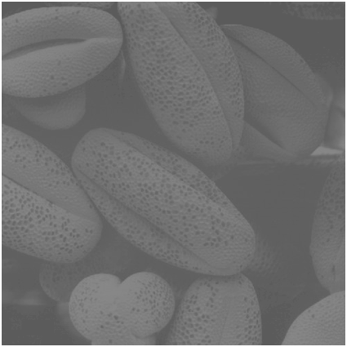 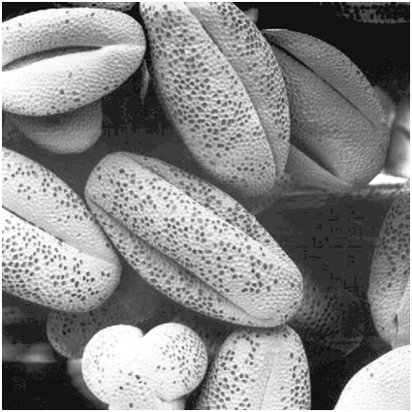

Input Image Output Image

1. **Take any of your photograph, match it’s histogram with the histogram of image ‘test4.jpg’. plot histogram of original image, template and matched image for all three channels.**

clc;

clear all;

close all;

r = imread("./7.jpg");

spec = imread("./test4.jpg");

%due to processing take long time i resize it,

%you can go with original 1417x1417 size.

spec = imresize(spec,[500,500]);

%Original image

figure;

imshow(r);

%histogram of input images

figure;

subplot(1,3,1);

imhist(r(:,:,1));

title("r histogram original");

subplot(1,3,2);

imhist(r(:,:,2));

title("g histogram original");

subplot(1,3,3);

imhist(r(:,:,3));

title("b histogram original");

%Specific image

figure;

imshow(spec);

%histogram of input images

figure;

subplot(1,3,1);

imhist(spec(:,:,1));

title("r histogram specific");

subplot(1,3,2);

imhist(spec(:,:,2));

title("g histogram specific");

subplot(1,3,3);

imhist(spec(:,:,3));

title("b histogram specific");

%final image

final(:,:,1) = MyHistogramMatcher(r(:,:,1),spec(:,:,1));

final(:,:,2) = MyHistogramMatcher(r(:,:,2),spec(:,:,2));

final(:,:,3) = MyHistogramMatcher(r(:,:,3),spec(:,:,3));

figure;

imshow(final);

imwrite(final,"Ex5d.png");

%histogram of final image

figure;

subplot(1,3,1);

imhist(final(:,:,1));

title("r histogram final");

subplot(1,3,2);

imhist(final(:,:,2));

title("g histogram final");

subplot(1,3,3);

imhist(final(:,:,3));

title("b histogram final");



Specific Image

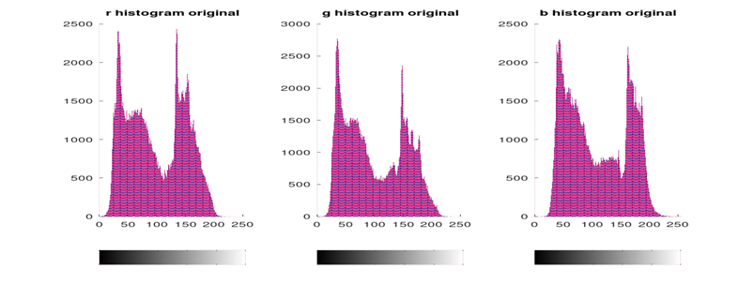

Histogram of Original

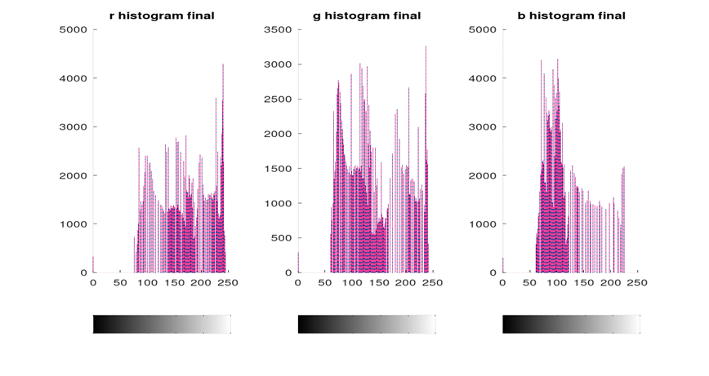

Histogram of final image

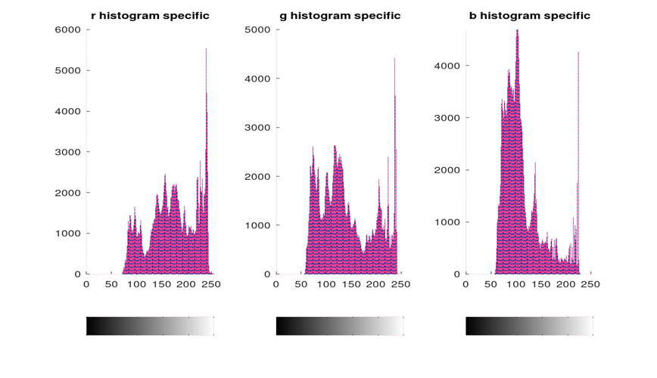

Histogram of Specific Image.